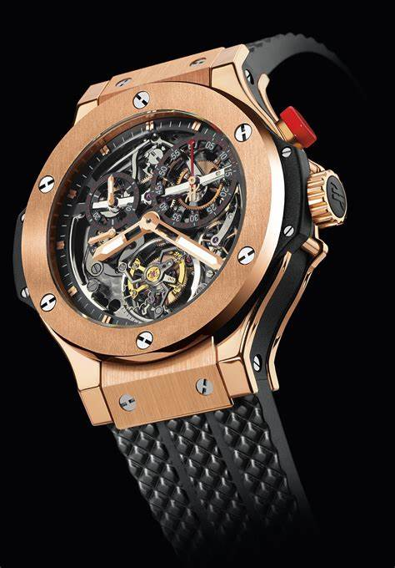Description: Hublot is a prestigious Swiss luxury watch brand known for its bold designs and innovative use of materials. Founded in 1980, the brand gained attention for its unique fusion of traditional Swiss watchmaking with modern aesthetics and cutting-edge technology. Hublot watches are recognized for their **bold, oversized cases, distinctive rubber straps**, and the fusion of materials like **titanium, ceramic, gold, and carbon fiber**. The brand’s iconic models, such as the **Big Bang**, often feature complex mechanisms, including chronographs, tourbillons, and flyback complications. Hublot is also known for collaborating with various sports, art, and fashion events, reinforcing its position as a symbol of luxury and innovation. With their premium craftsmanship and avant-garde designs, Hublot watches are highly sought after by collectors and enthusiasts worldwide.